

**Jung-Meyers-Briggs Assessment**

1. Go to [www.wois.org](http://www.wois.org) and log on with your **Site Key**.



1. Log in with your **User ID** and **Password**



1. Click **Log in**
2. Click on “**Assessments”** in the navigation panel on the left side of the screen.
3. Click on **“Other Assessments.”**
4. Click **Jung-Myers-Briggs typological approach** to begin the assessment. 



1. This will take you to the **HumanMetrics** site
2. To start the test click **“Do it”** button.



1. When you finish answering all the questions, click **“Score it.”**
2. This will provide the results of your test and give you your type. **\*Do not close the results window!**



1. Go back to WOIS and click **Portfolio** then **Assessments/Tests.**



1. Click **“Add New Assessment”**

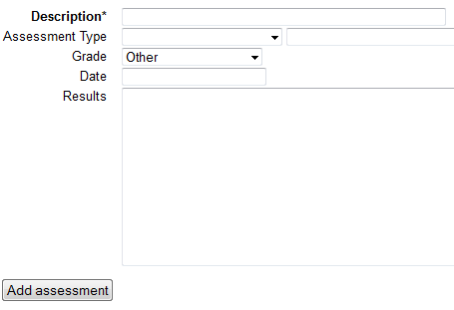

1. Fill in the information based on your **Jung-Myers-Briggs** assessment and click **“Add Assessment.”**
2. Your results will now show under the **Assessments**.